Computer Architecture Project
Computer Architecture Simulator and Design

Project Overview
The Computer Architecture Project is designed to demonstrate the fundamental concepts of computer system organization and architecture.
This project focuses on understanding how a computer processes instructions, performs arithmetic and logical operations, manages memory, communicates with input/output devices, and executes instructions through pipelining.
The project consists of five major modules:
- CPU Architecture
- Instruction Set Architecture (ISA)
- Memory Hierarchy
- Input/Output System
- Instruction Pipelining
Each module demonstrates an important component of computer architecture and explains how different hardware components work together.

Project Objectives
- Understand the internal organization of a computer system.
- Study CPU components and their functions.
- Understand instruction formats and execution.
- Explore memory hierarchy and memory access.
- Understand input/output communication.
- Study instruction pipelining.
- Understand pipeline hazards and their solutions.
- Demonstrate the working of computer architecture components.
- Develop practical knowledge of low-level system operations.

System Architecture
A computer system consists of several interconnected components that work together to execute instructions and process data.
Computer System Architecture Diagram
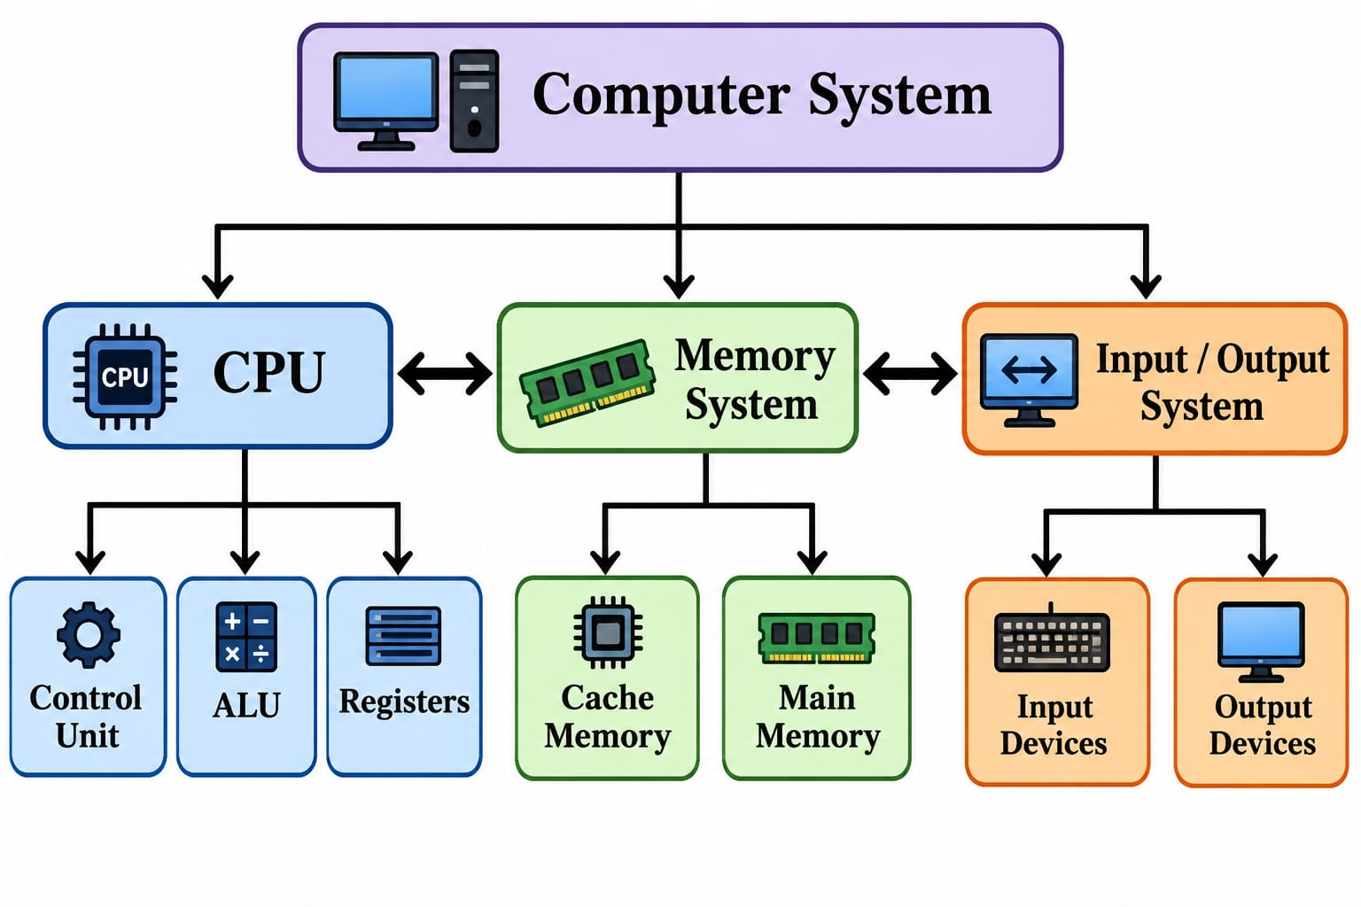Architecture Components
Component | Description
CPU | Executes instructions and processes data
Control Unit | Controls instruction execution
ALU | Performs arithmetic and logical operations
Registers | Store temporary data and instructions
Cache | Stores frequently accessed data
Main Memory | Stores currently running programs and data
Input Devices | Provide data to the computer
Output Devices | Display or produce processed results

Project Modules
1. CPU Architecture
Introduction
The CPU is the main processing unit of a computer system.
It executes instructions, performs calculations, and controls the operations of other components.
The CPU consists of the Arithmetic Logic Unit, Control Unit, and Registers.
Features
- Arithmetic operations
- Logical operations
- Data processing
- Register operations
- Instruction control
- Data transfer between registers
- ALU operation selection
- Status flag generation
- CPU component visualization
- Instruction execution monitoring
CPU Components
Component | Function
ALU | Performs arithmetic and logical operations
Control Unit | Generates control signals
Registers | Store temporary values
Program Counter (PC) | Holds the address of the next instruction
Instruction Register (IR) | Holds the current instruction
Status Register | Stores condition flags
CPU Architecture Diagram
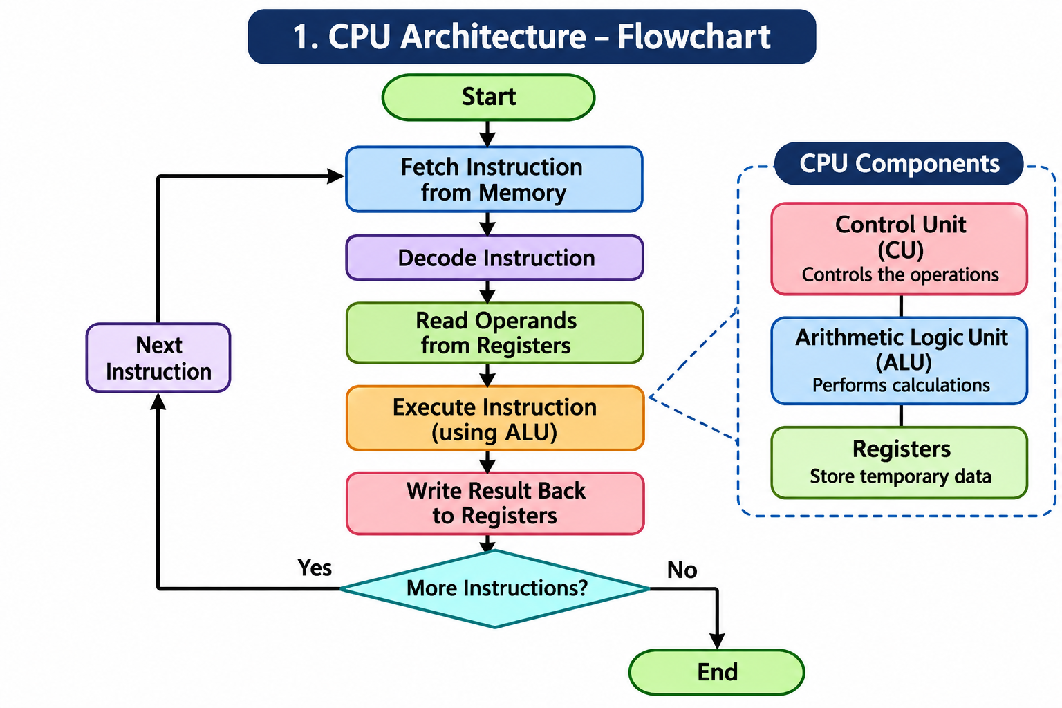
ALU Operations
Operation | Description
ADD | Addition
SUB | Subtraction
AND | Bitwise AND
OR | Bitwise OR
XOR | Bitwise XOR
NOT | Bitwise NOT
Shift Left | Shifts bits to the left
Shift Right | Shifts bits to the right

2. Instruction Set Architecture (ISA)
Introduction
Instruction Set Architecture defines the instructions that a processor can execute.
It acts as an interface between software and hardware.
ISA specifies instruction formats, registers, addressing modes, and operations supported by a processor.
Features
- Instruction formats
- Opcode identification
- Instruction decoding
- Register-based instructions
- Immediate instructions
- Memory access instructions
- Arithmetic instructions
- Logical instructions
- Branch and jump instructions
- Instruction execution
- Addressing modes
- Instruction representation
Instruction Categories
Category | Example | Purpose
Arithmetic | ADD, SUB | Mathematical operations
Logical | AND, OR, XOR | Logical operations
Data Transfer | LOAD, STORE | Memory data transfer
Branch | BEQ, BNE | Conditional control flow
Jump | JAL, JALR | Unconditional control flow
Instruction Execution Diagram
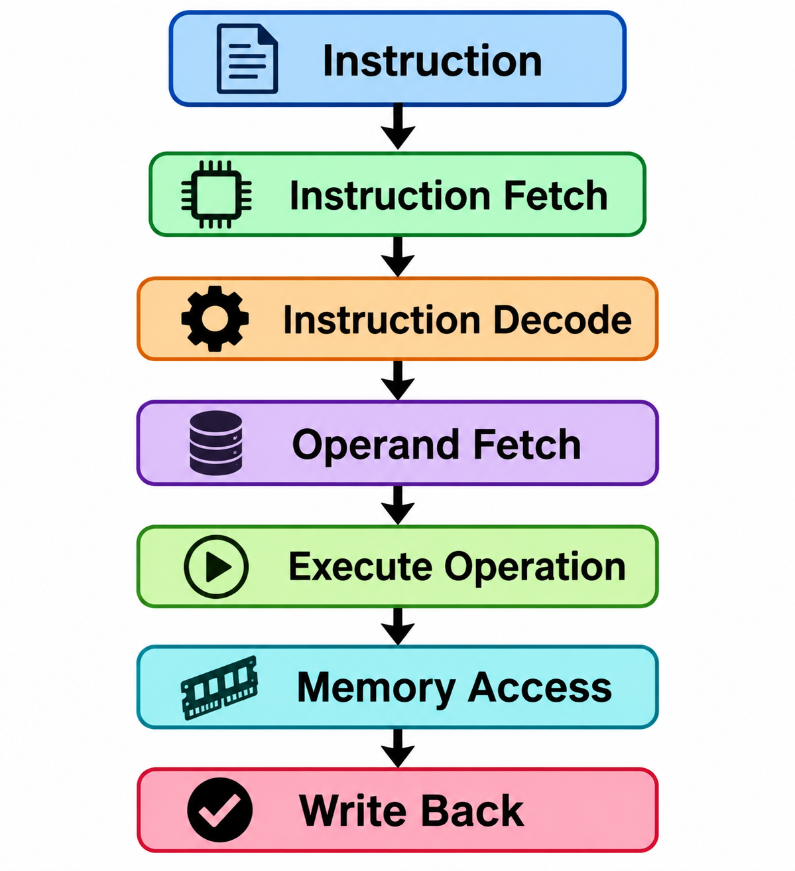
3. Memory Hierarchy
Introduction
Memory Hierarchy organizes computer memory according to speed, capacity, and cost.
Frequently accessed data is stored in faster memory, while larger amounts of data are stored in slower memory.
Features
- Cache memory
- Main memory
- Memory access
- Memory read operations
- Memory write operations
- Cache hit and miss
- Memory hierarchy visualization
- Memory performance analysis
- Memory latency comparison
- Data transfer between memory levels
Memory Hierarchy Diagram
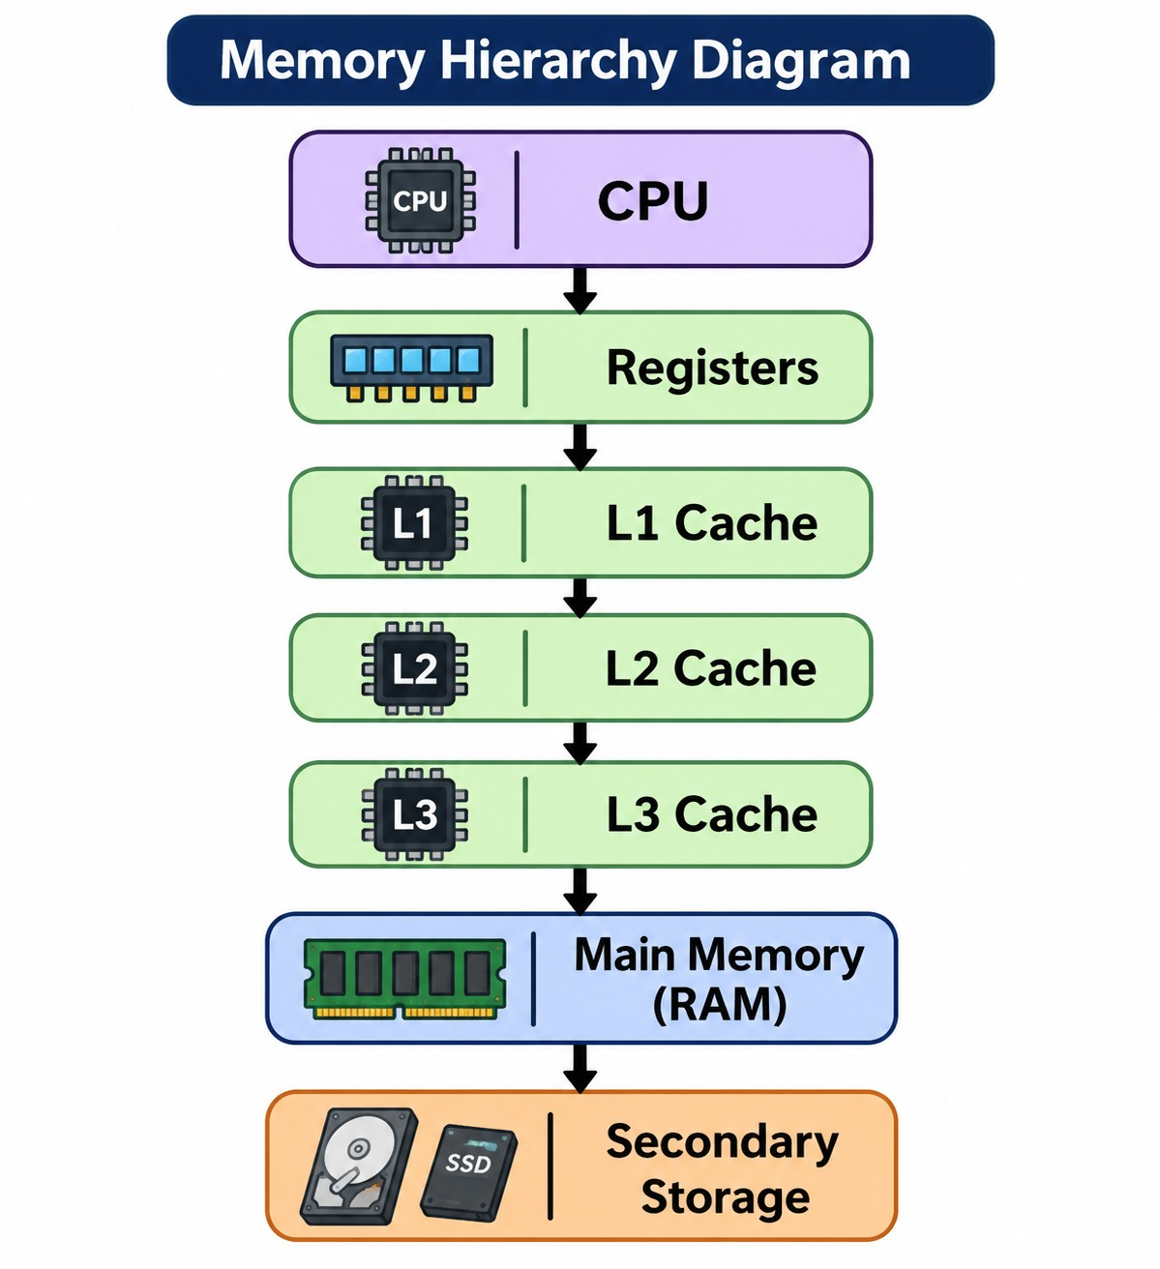
Memory Characteristics
Memory Level | Speed | Capacity
Registers | Very High | Very Small
L1 Cache | Very High | Small
L2 Cache | High | Small to Medium
L3 Cache | Medium to High | Medium
RAM | Medium | Large
Secondary Storage | Low | Very Large
Cache Operation Diagram
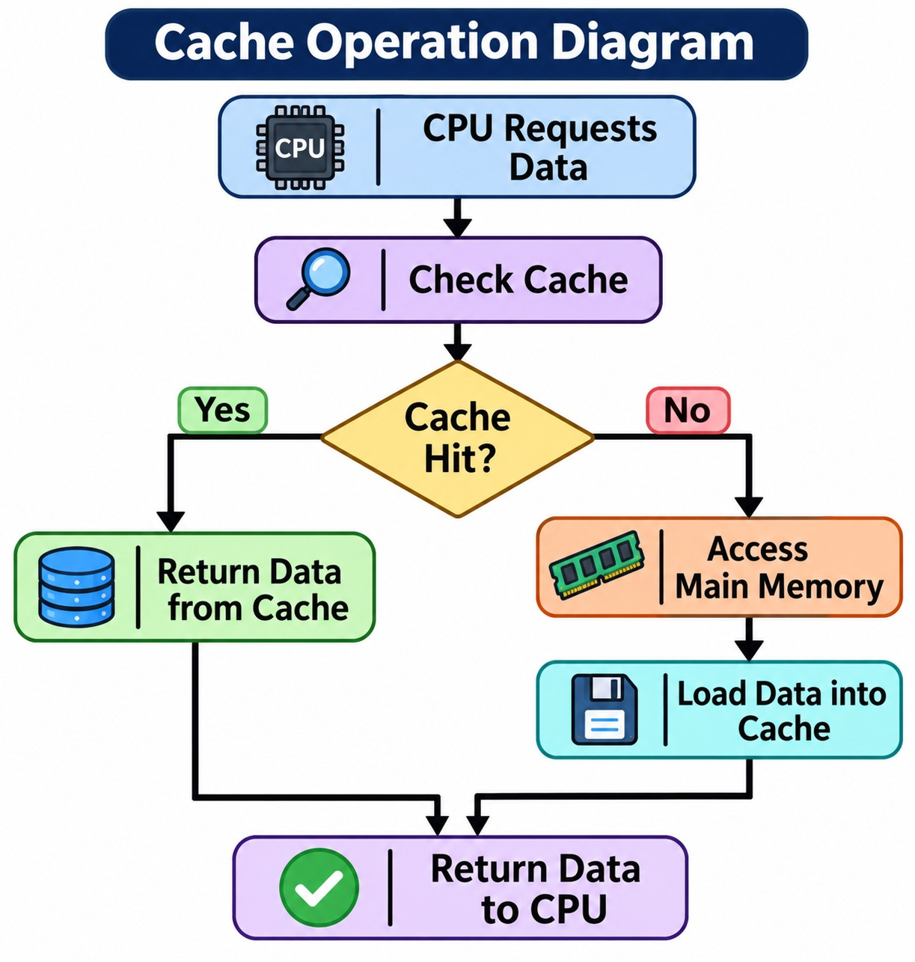Cache Performance
- Cache Hit: Requested data is available in cache.
- Cache Miss: Requested data is not available in cache.
- Hit Rate: Percentage of memory requests found in cache.
- Miss Rate: Percentage of memory requests not found in cache.

4. Input/Output System
Introduction
The Input/Output System manages communication between the computer and external devices.
It allows the computer to receive input, process information, and send output.
Features
- Input device management
- Output device management
- Device communication
- Data transfer
- I/O controller operations
- Programmed I/O
- Interrupt-driven I/O
- Direct Memory Access (DMA)
- Device status monitoring
- Input/output operation visualization
I/O Devices
Input Devices | Output Devices
Keyboard | Monitor
Mouse | Printer
Scanner | Speakers
Microphone | Display
I/O System Diagram
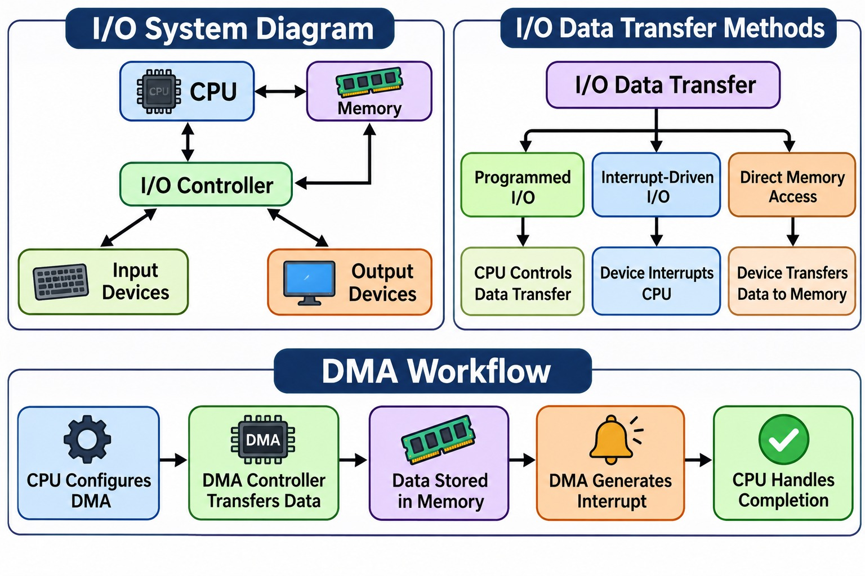
5. Instruction Pipelining
Introduction
Instruction Pipelining is a technique that improves processor performance by overlapping the execution of multiple instructions.
Instead of completing one instruction before starting another, the processor works on different stages of multiple instructions simultaneously.
Features
- Instruction pipeline stages
- Instruction overlap
- Pipeline performance
- Pipeline throughput
- Pipeline hazards
- Data hazard detection
- Control hazard handling
- Structural hazard handling
- Pipeline stall
- Pipeline forwarding
- Pipeline visualization
Five-Stage Pipeline
Stage | Name | Function
IF | Instruction Fetch | Fetch instruction from memory
ID | Instruction Decode | Decode instruction
EX | Execute | Perform operation
MEM | Memory Access | Access memory
WB | Write Back | Write result to register
Pipeline Architecture Diagram
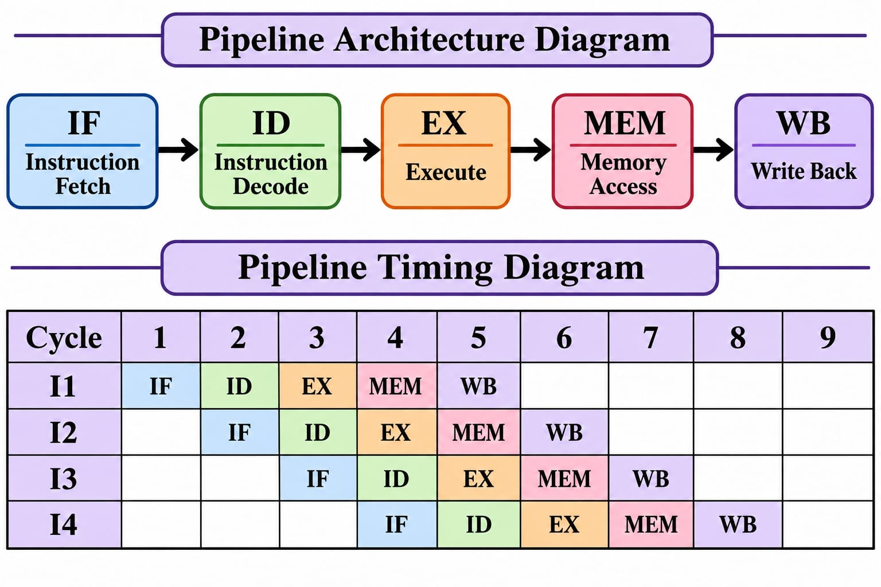
Pipeline Hazards
A pipeline hazard occurs when an instruction cannot execute in its expected pipeline stage.
Hazard | Description
Structural Hazard | Hardware resource conflict
Data Hazard | Dependency between instructions
Control Hazard | Branch or jump changes instruction flow
Pipeline Hazard Diagram
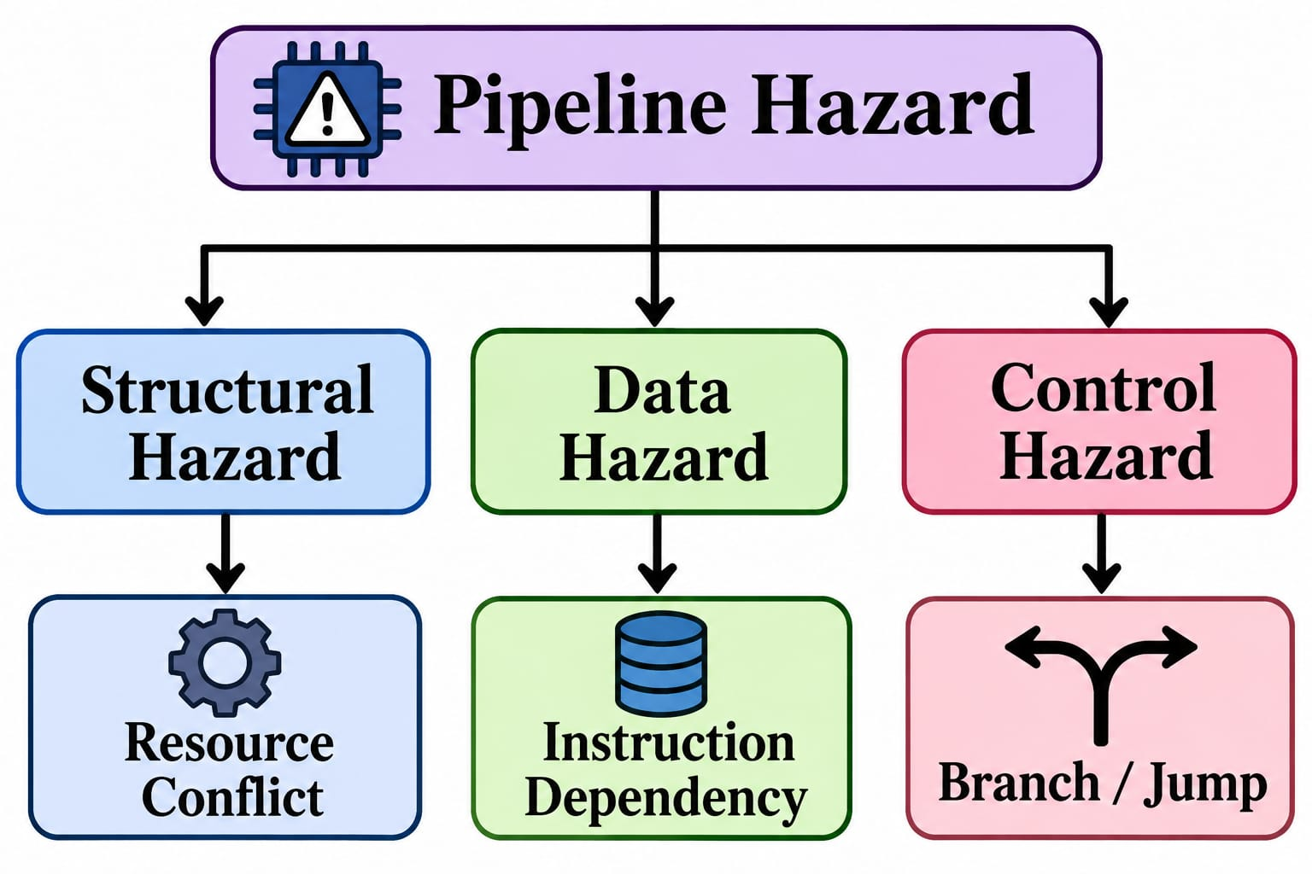
Hazard Handling
- Pipeline stalls
- Data forwarding
- Hazard detection
- Branch prediction
- Pipeline flushing

Module Interaction
The five modules work together to demonstrate the complete instruction processing system.
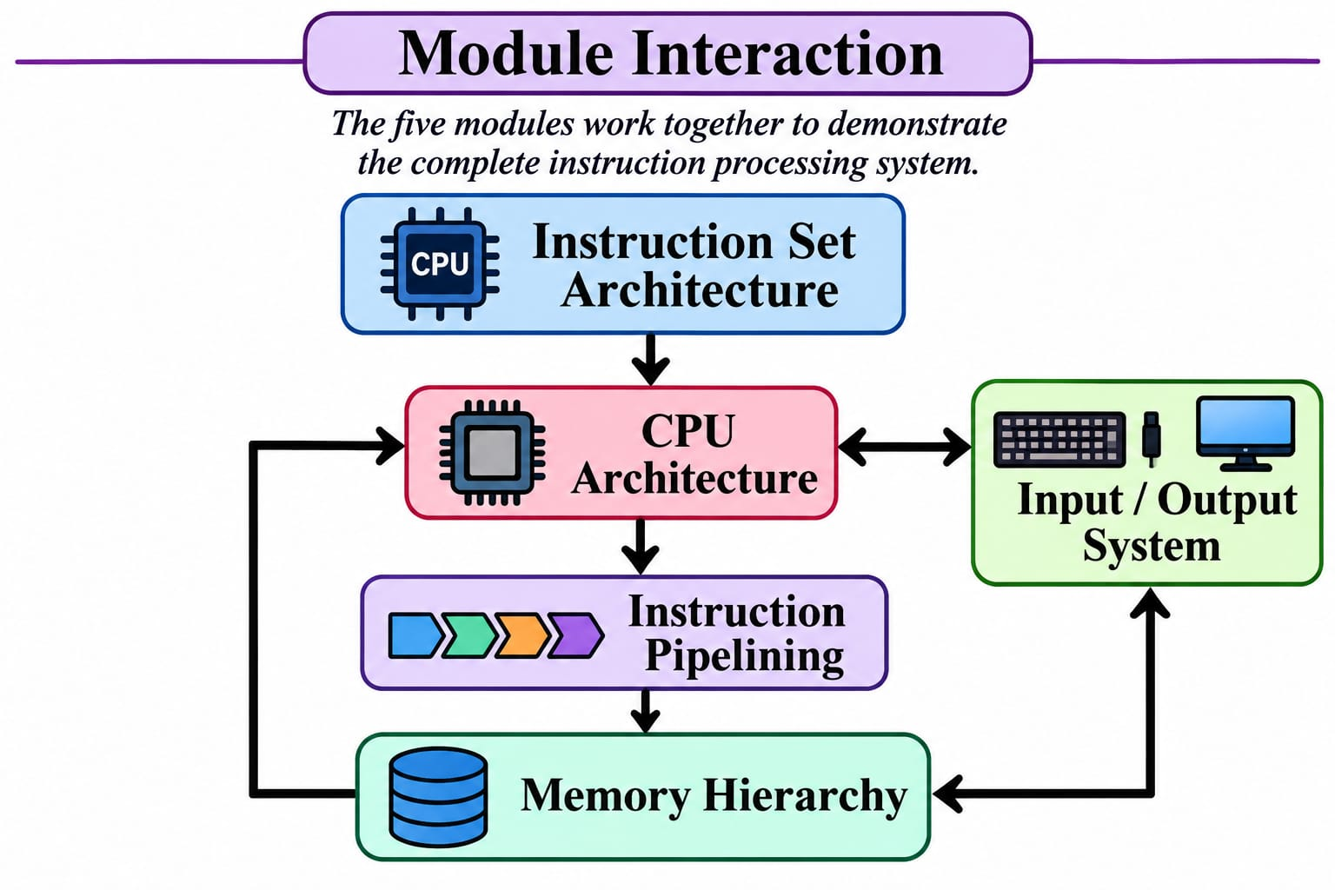
Interaction Description
- ISA defines the instructions.
- CPU Architecture executes instructions.
- Memory Hierarchy supplies instructions and data.
- Input/Output System communicates with external devices.
- Pipelining improves instruction execution throughput.

Overall Working Flow
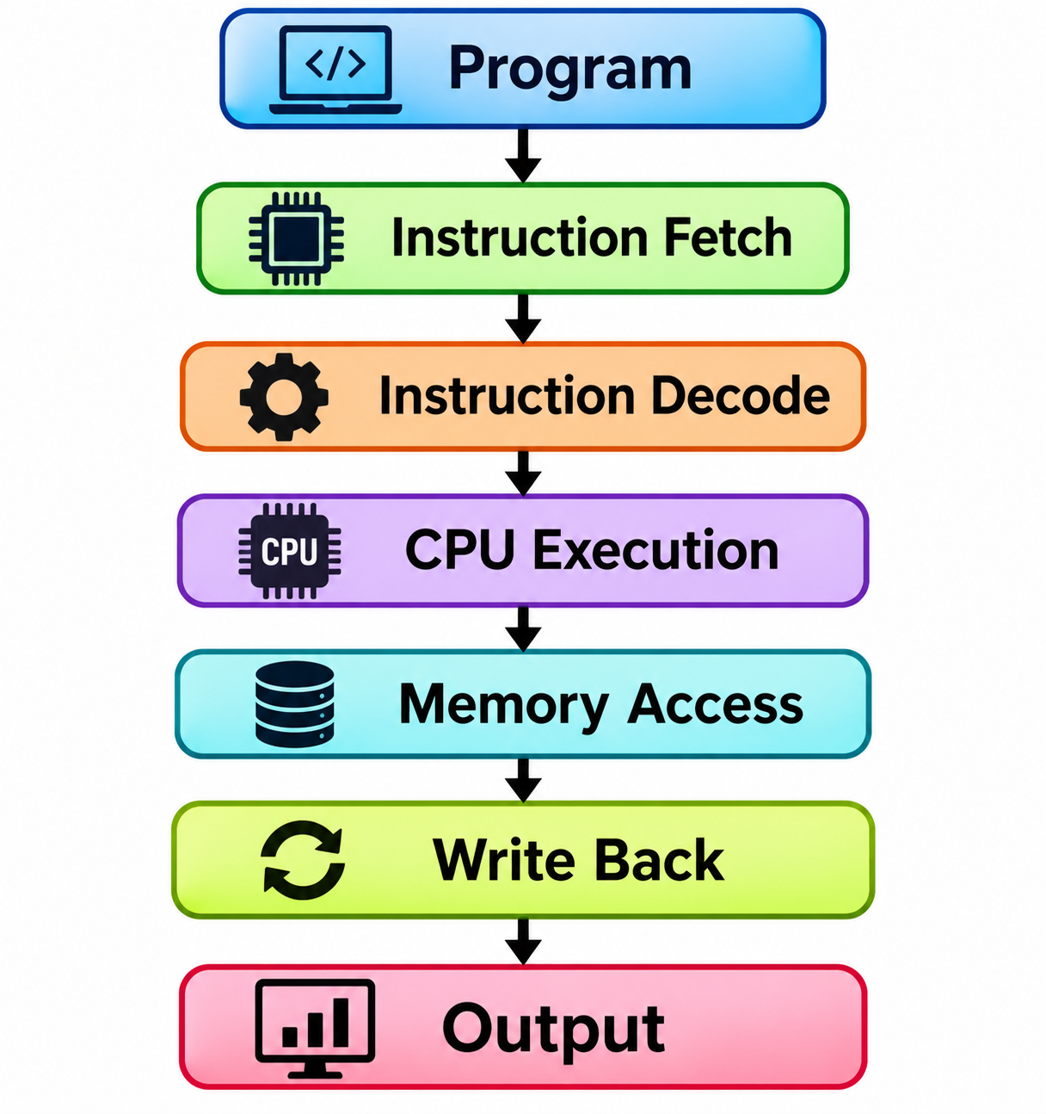
Project Structure
The following structure represents the planned organization of the Computer Architecture project.
Computer-Architecture/
│
├── README.md
│
├── CPU-Architecture/
│ ├── ALU
│ ├── Control-Unit
│ └── Registers
│
├── Instruction-Set-Architecture/
│ ├── Instruction-Formats
│ ├── Opcodes
│ └── Instruction-Execution
│
├── Memory-Hierarchy/
│ ├── Cache
│ ├── RAM
│ └── Memory-Access
│
├── Input-Output-System/
│ ├── Input-Devices
│ ├── Output-Devices
│ └── Data-Transfer
│
├── Pipelining/
│ ├── Pipeline-Stages
│ ├── Hazard-Detection
│ └── Pipeline-Performance
│
└── docs/
├── architecture.md
├── module-design.md
└── testing.md
Note: This is a planned structure. Actual file names and directories may change during implementation.

Technologies Used
Technology | Purpose
C Language | Low-level programming
Assembly Language | Instruction-level operations
RISC-V | Instruction set reference
VS Code | Development environment
Git | Version control
GitHub | Project repository
Testing and Evaluation
The project will be evaluated through functional and architectural testing.
Testing Areas
- CPU arithmetic and logical operations
- Instruction decoding
- Register operations
- Memory access operations
- Cache hit and miss behavior
- I/O data transfer
- Pipeline execution
- Pipeline hazard handling
- Performance comparison
Expected Results
- Demonstrate the working of five architecture modules.
- Understand how CPU components interact.
- Demonstrate instruction execution.
- Understand memory access and cache performance.
- Explain I/O communication.
- Demonstrate instruction pipelining.
- Understand pipeline hazards and their handling.

Future Enhancements
- Advanced CPU design
- Cache replacement algorithms
- Advanced instruction formats
- Branch prediction
- Pipeline performance comparison
- RISC-V instruction simulator
- Hardware component visualization
- Advanced memory management
- Performance analysis

References
- RISC-V International
- RISC-V Specifications
- Computer Architecture: A Quantitative Approach
- Computer Organization and Design

Conclusion
The Computer Architecture Project provides a practical understanding of computer system organization and operation.
Through five major modules, the project demonstrates how the CPU executes instructions, how memory stores data, how I/O devices communicate, and how pipelining improves processor performance.
The project aims to strengthen the understanding of computer architecture through practical implementation, visualization, and testing.

